**Practical - 3**

**Aim:**

**Write an assembly program for below given fragments of C program**

1. **void main ()**

**{**

**int l,m,n,o,p;**

**l = m+n-o+p;**

**}**

1. **C = (F – 32) * 5 / 9**

**Description of instructions used:**

MOV: Transfer data from one register or memory location to another register or memory location.

ADD: Adds immediate data or memory location or register to memory location or register. Source and destination for ADD can’t be memory location.

SUB: Subtracts immediate data or memory location or register to memory location or register. Source and destination for SUB can’t be memory location.

DB: Bytes are allocated by define bytes DB.

DUP: DUP allows to allocate multiple bytes.

The following two lines produce identical results:DB ?, ?, ?, ?, ? **OR** DB 5 DUP(?)

**PROGRAM:1**

**Code:**

.model code1

.data

M DB 05H

N DB 02H

O DB 03H

P DB 04H

L DB 00H

.code

MOV AX, data

MOV DS,AX

MOV AL,M

MOV BL,N

ADD AL,BL

MOV BL,O

SUB AL,BL

MOV BL,P

ADD AL,BL

MOV L,AL

END

**Output:**

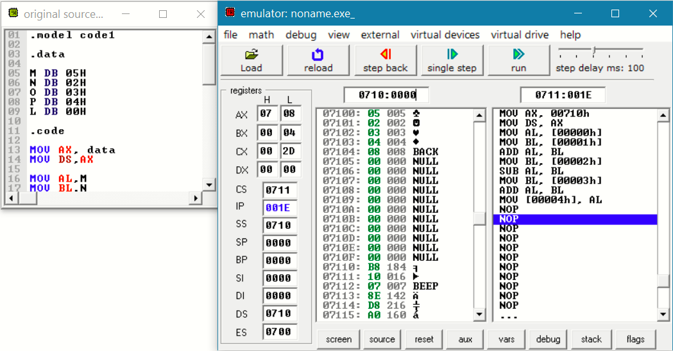

**PROGRAM:2**

In this program, first of all we have to convert decimal number to hexadecimal number therefore we have to convert 32, 5 and 9 in hexadecimal. Therefore hexadecimal value is 20, 5 and 9. In this practical we will put F value as static.

**Code:**

.model .code1

.data

F DB 50H

M DB 32H

N DB 05H

O DB 09H

C DB 00H

.code

mov ax,data

mov ds,ax

mov al,F

mov bl,M

sub al,bl

mov bl,N

mul bl

mov bl,O

div bl

mov C,al

END

**Output:**

